Go to **manage Jenkins 🡪manage users** and create a user

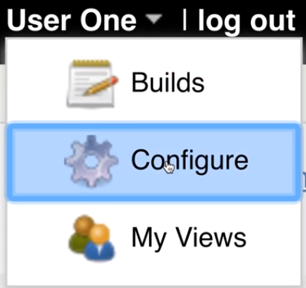

* After logging into the user, we can go to configure and change username or password

There are 3 important security strategies in Jenkins to manage the users. We can check those in global security settings

* **Matrix based security**
* **Project based strategy**
* **Role based strategy**

**Matrix based strategy:**

* Matrix based strategy is a simple strategy to give the permissions as below

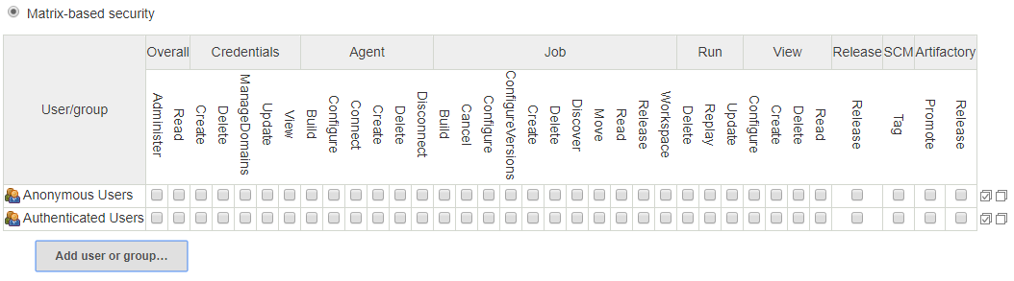

* We can add the created users and give them the permissions as per the requirement

**Project based strategy:**

* We can give the below overall access to the user

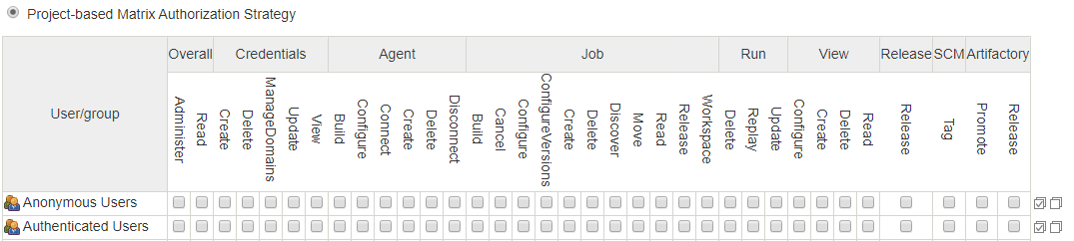

* But if we want to restrict in the job level. We can go to job configuration, add the user and enable the access to the user for only that particular user as below

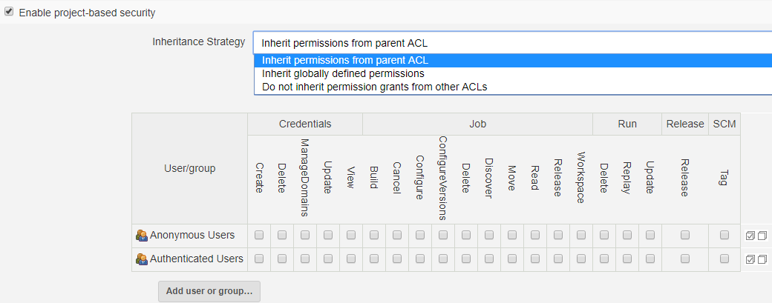

**Role based strategy:**

* We need to download roles strategy plugin to set roles on users
* Login as an admin, now in configure global security, enable the security

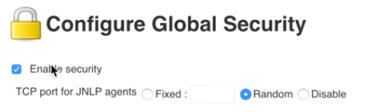

* Under authorization section, we can now find the role-based strategy as below

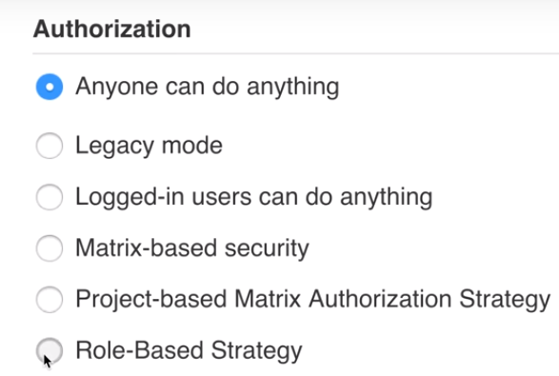

* Now, if we try to login with the created user, we can’t do it as now we are using role-based strategy authorization
* Now, go to manage and assign roles under manage Jenkins. We can see below

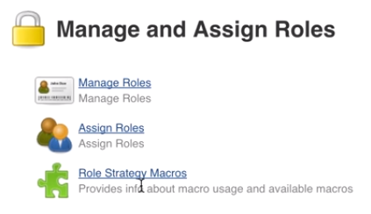

* Inside manage roles, we can find global roles, project roles and slave roles
* Global role is for global. We can create new role and assign permissions

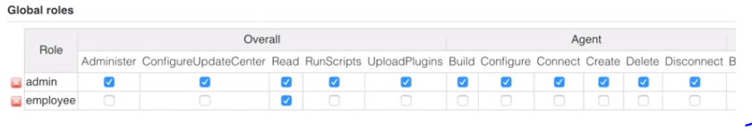

* Project roles used for the permissions on projects

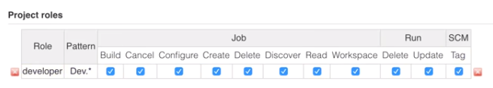

* Here pattern dev.* means the projects that starts with dev
* And then we can go to assign roles to add users and assign roles to them

